Project | Project Name  September, 2012
Charter | Project Name  September, 2012

- Purpose of this Charter

A project charter is a document that describes what the project will accomplish. It is meant to convey to all who review it the key aspects of the project and includes a description of the scope, any known risks, issues, constraints and dependencies that are already known to exist for the project. It provides the project manager with an anchor point to refer to if there are large scale changes to scope, timelines or costs.

This document is an approval document. It indicates that key stakeholders agree to the scope, budget and timelines specified and that they support the project and will ensure its success.

- Project Description

A description of the project is supplied here. The description should be as concise as possible but should not go into minutiae about every detail of the project. At a minimum it should include the following:

Scope:

- A clear description of the objectives.
- A clear description of the deliverables that will help achieve the objectives.
- A clear description of the work required to produce the deliverables.
- Clarity about the boundaries of the project – what is in scope and equally importantly – what is out of scope.

Success Criteria:

- Success Factor 1
- Success Factor 2
- Success Factor 3…

Assumptions:

Assumption | Impact / Consequence if the Assumption is not true
Assumption 1 | - Project is late (how much)  - Project costs more (how much)  - More risk (how much)
Assumption 2 | - Project is late (how much)  - Project costs more (how much)  - More risk (how much

Dependencies:
A dependency is reliance on the occurrence of an event or activity that is external to this project, in order for certain project milestones or deliverables to be initiated or completed. Examples are dependencies on other systems or projects, infrastructure, availability of external resources, and business deliverables or activities. This project is subject to the following dependencies:

Dependency Description | Due Date
Dependency 1

Dependency 2

Constraints

Constraints are things that might restrict, limit, or regulate the Project. This Project will be constrained by the following factors.

# | Constraint

Risks

Risk Management focuses on identifying known threats and opportunities that may have an effect on the project’s success.

The following table lists the known risks that have been identified by project stakeholders.

# | Risk | Probability (H/M/L) | Impact (H/M/L) | Risk Response

- Project Schedule

A high level overview of the project schedule should be provided. This will be detailed to a much greater extent in the project management plan but serves as an initial indication of the timelines required to complete the project.

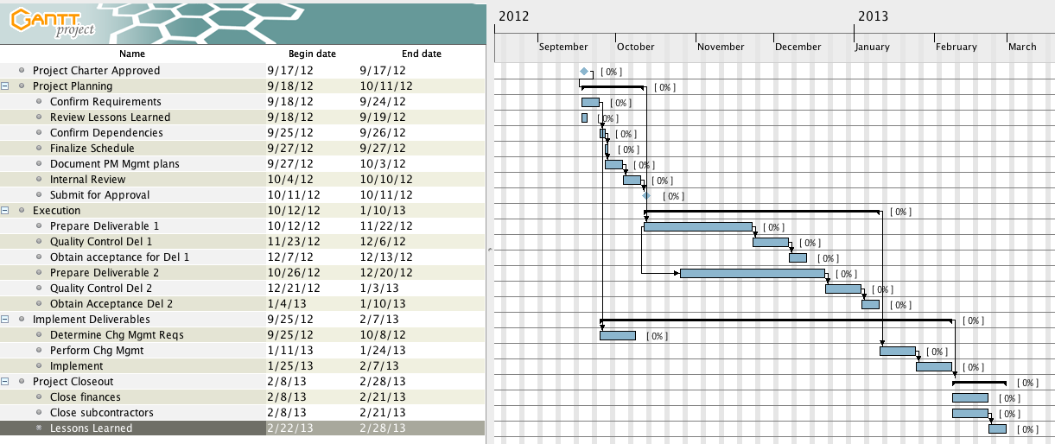

- Project Budget

The high level budget describes the anticipated costs (and revenues if appropriate) for this project.

LABOUR

Project Component | Resource(s) | Estimated Effort  (in days) | Estimated Project Cost
Resources | Admin Support
 | Media Consultants
 | Ticket Specialist
 | Project Manager
 | Subtotal:
Project Resources Totals: |  |  | $ 0

EQUIPMENT AND SERVICES
Estimated Cost
Photocopying
Office Space
Back hoe
Banking Fees
Hardware/Software Total:

- Project Organization

Governance

Quantify the thresholds for escalating decisions within the above Governance structure so that the Decision Management process can be used throughout the project. The thresholds should address how decisions relating to changes in scope, cost, schedule, and quality will be dealt with.

Roles & Accountabilities

All entities in the Governance Chart must be represented in the following table. The accountabilities listed are examples and should be reviewed and adjusted for this Project.

Role | Accountability
Steering Committee | - Provide final authority on resolution of major project issues outside the control of the sponsor  - Receive project updates  - Recommend approval of project scope, schedule and budget  - Participate in on-going project communication processes
Project Sponsor | - Define objectives  - Define business requirements  - Ensure achievement of objectives  - Review and approve scope, schedule and budget  - Review and approve scope, schedule and budget changes  - Review and approve deliverables  - Provide decisions / resolution of escalated issues  - Review and authorize overall budget  - Assess overall benefits  - Ensure delivery of benefits
Project Manager | - Ensure the project or initiative outcomes meet the business objectives.  - Ensure project delivery meets contract specifications according to scope, budget and quality expectations  - Coordinate services provided by other groups and integrate activities into broader plans to deliver on schedule and budget  - Prepare and assemble all project, business and service measure reporting requirements on a timely basis  - Manage and track project inter-dependencies  - Serve as the internal escalation point for project issues and escalate issues involving significant risk to the appropriate governance body.  - Establish and maintain effective vendor and stakeholder relationship management  - Ensure all administrative processes are performed including but not limited to budget reporting, deliverable reporting, performance reporting, decision request creation, information security requirements, and privacy requirements  - Establish and maintain a high level of business trust and confidence in the team’s knowledge of and concern for business requirements and issues  - Work with the business to minimize the impact of change
More Resources here

More Resources here

More Resources here

- Terms, Acronyms and Abbreviations

Term/Acronym | Description

- Resource Requirements

This section of the charter describes what resources will be required to complete the project. This is especially important if the project requires participation from other employees in the company. The idea is that the project is reserving access to key individuals who are required to complete the project.

Resource #1 | Resource Name (if known – else title)
Role:

Commitment Requirements: | e.g. 50% for the first 3 months of the project. 10% for the remainder
Total Expected Hours for this resource:
Approved by: | Name of the supervisor for the required resource
Date Approved

Resource #2 | Resource Name (if known – else title)
Role:

Commitment Requirements: | e.g. 50% for the first 3 months of the project. 10% for the remainder
Total Expected Hours for this resource:
Approved by: | Name of the supervisor for the required resource
Date Approved

Resource #3 | Resource Name (if known – else title)
Role:

Commitment Requirements: | e.g. 50% for the first 3 months of the project. 10% for the remainder
Total Expected Hours for this resource:
Approved by: | Name of the supervisor for the required resource
Date Approved

- Project Charter Approval

Name

Title

Comments
(optional)

Date Approved:

Name

Title

Comments
(optional)

Date Approved:

Name

Title

Comments
(optional)

Date Approved:

